**Video Session Assignment – Day 4**

* Create login page
* After submitting login form, it should move to login servlet for validating username and password
* If credentials are correct then it should create session and will be redirected to user homepage then print username over JSP
* If credentials are incorrect then should reload login page for user to attempt to login again
* Create logout link on homepage
* When user logouts then it will terminate the session by calling logout servlet
* Provide blogger parameters using servlet context
* Provide admin user details using servlet config

**The Latte Lounge Project Structure**

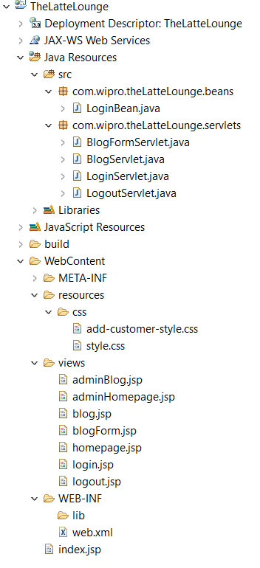

**Add-customer-style.css**

**Note: This is a file I re-used from a previous project demonstration that I was following for SpringMVC and is not my code.**

**form** {

margin-top: *10px*;

}

**label** {

font-size: *16px*;

width: *100px*;

display: *block*;

text-align: *right*;

margin-right: *10px*;

margin-top: *8px*;

margin-bottom: *8px*;

}

**input** {

width: *250px*;

border: *1px* *solid* *#666*;

border-radius: *5px*;

padding: *4px*;

font-size: *16px*;

}

*.save* {

font-weight: *bold*;

width: *130px*;

padding: *5px* *10px*;

margin-top: *30px*;

background: *#cccccc*;

}

**table** {

border-style:*none*;

width:*50%*;

}

**tr***:nth-child(even)* {background: *#FFFFFF*}

**tr***:nth-child(odd)* {background: *#FFFFFF*}

**tr** {

border-style:*none*;

text-align:*left*;

}

**Style.css**

**Note: This is a file I re-used from a previous project demonstration that I was following for SpringMVC and is not my code.**

**html,** **body**{

margin-left:*15px*; margin-right:*15px*;

padding:*0px*;

font-family:*Verdana,* *Arial,* *Helvetica,* *sans-serif*;

}

**table** {

border-collapse:*collapse*;

border-bottom:*1px* *solid* *gray*;

font-family: *Tahoma,Verdana,Segoe,sans-serif*;

width:*72%*;

}

**th** {

border-bottom:*1px* *solid* *gray*;

background:*none* *repeat* *scroll* *0* *0* *#09c332*;

padding:*10px*;

color: *#FFFFFF*;

}

**tr** {

border-top:*1px* *solid* *gray*;

text-align:*center*;

}

**tr***:nth-child(even)* {background: *#FFFFFF*}

**tr***:nth-child(odd)* {background: *#BBBBBB*}

*#wrapper* {width: *100%*; margin-top: *0px*; }

*#header* {width: *70%*; background: *#09c332*; margin-top: *0px*; padding:*15px* *0px* *15px* *15px*;}

*#header* **h2** {width: *100%*; margin:*auto*; color: *#FFFFFF*;}

*#container* {width: *100%*; margin:*auto*}

*#container* **h3** {color: *#000*;}

*#container* *#content* {margin-top: *20px*;}

*.add-button* {

border: *1px* *solid* *#666*;

border-radius: *5px*;

padding: *4px*;

font-size: *12px*;

font-weight: *bold*;

width: *120px*;

padding: *5px* *10px*;

margin-bottom: *15px*;

background: *#cccccc*;

}

**LoginBean.java**

**package** com.wipro.theLatteLounge.beans;

**public** **class** LoginBean {

**private** String username;

**private** String password;

**public** LoginBean() {

}

**public** **void** setUsername(String username) {

**this**.username = username;

}

**public** **void** setPassword(String password) {

**this**.password = password;

}

**public** String getUsername() {

**return** username;

}

**public** String getPassword() {

**return** password;

}

@Override

**public** String toString() {

**return** "Username: " + username;

}

}

**Login.jsp**

<%@ page language=*"java"* contentType=*"text/html; charset=ISO-8859-1"*

pageEncoding=*"ISO-8859-1"*%>

<!DOCTYPE html PUBLIC "-//W3C//DTD HTML 4.01 Transitional//EN" "http://www.w3.org/TR/html4/loose.dtd">

<html>

<head>

<meta http-equiv=*"Content-Type"* content=*"text/html; charset=ISO-8859-1"*>

<title>Login</title>

<!-- reference our style sheet -->

<link type=*"text/css"*

rel=*"stylesheet"*

href=*"*${pageContext.request.contextPath}*/resources/css/style.css"* />

<link type=*"text/css"*

rel=*"stylesheet"*

href=*"*${pageContext.request.contextPath}*/resources/css/add-customer-style.css"* />

</head>

<body>

<div id=*"wrapper"*>

<div id=*"header"*>

<h2>Customer Login</h2>

</div>

</div>

<form action=*"*${pageContext.request.contextPath}*/Login"* method=*"post"*>

<table>

<tbody>

<tr>

<td><label>User name:</label></td>

<td><input type = *"text"* name = *"username"*/></td>

</tr>

<tr>

<td><label>Password:</label></td>

<td><input type = *"text"* name = *"password"*/></td>

</tr>

<tr>

<td><label></label></td>

<td><input type=*"submit"* value=*"Submit"*/></td>

</tr>

</tbody>

</table>

</form>

</body>

</html>

**LoginServlet.java**

